NEA

By Kamran Bhatti

Harris Academy South Norwood

Computer Science

**Analysis:**

Problem Background

I believe that the exposure of children to profanity in social media has been the driving force for them to develop aggressive tendencies and has caused academic hindrances. In my experience, students who use social media devote a large portion of their time digesting the latest trends or gossip that was circulating at the time due to having all of this information accessible from the click of a button. The allure of social media is to allow people to stay in touch with peers, all the while, students become consumed by their need to maintain their digital presence rather than how they choose to be represented in real life as shown by a lack of interest in their own education as it is not as intriguing or emotionally stimulating. In modern society students are, on occasion, not monitored when on their digital devices, thus causing students to give into temptation and peruse the internet for the latest gossip causing their studies to be neglected. This correlation leads to students who frequent social media to attain lower grades than their counterparts causing some students to become antisocial coupled with a lack of communication skills which deprive students of future opportunities to develop their academic careers. Additionally, students may encounter forms of cyber bullying which could cultivate self-harming, having suicidal thoughts or isolating themselves both in reality and virtually. While being led to believe that they are ostracised by everyone around them, these individuals may adopt the notion that they are unable to access avenues which could provide them the guidance or help they need. However, the greatest threat these students face is their own naivety; from succumbing to peer pressure by posting unfavourable content to being coerced into sharing explicit images. Whilst not understanding the detrimental ramifications of their actions, any future opportunities to seek employment or further their academic career to their privacy online could all be relinquished as they do not realise that what is on the internet leaves a trail that once posted can’t be expunged. I propose that it would be beneficial for schools to endorse students using a platform that the institution can monitor which will eventually lead to students being able to maintain both a virtual presence and academic career. In turn, this will help alleviate the threats of normal social media and will nurture students in a safe online environment.

Researching and Refining the Problem

Designing and Distribution of Surveys

Firstly I wished to gather data from a range of people from my target age group, which I decided would consist of Year Seven to Upper Sixth Form; ages at which students are generally introduced to social media or frequent the use of social media within their daily lives. In order to gather the data I required I distributed surveys to Year 7, 8, 9, 10, 11 and the Sixth Form at Harris Academy South Norwood. An example survey is shown below:

Questionnaire 1 in Google forms

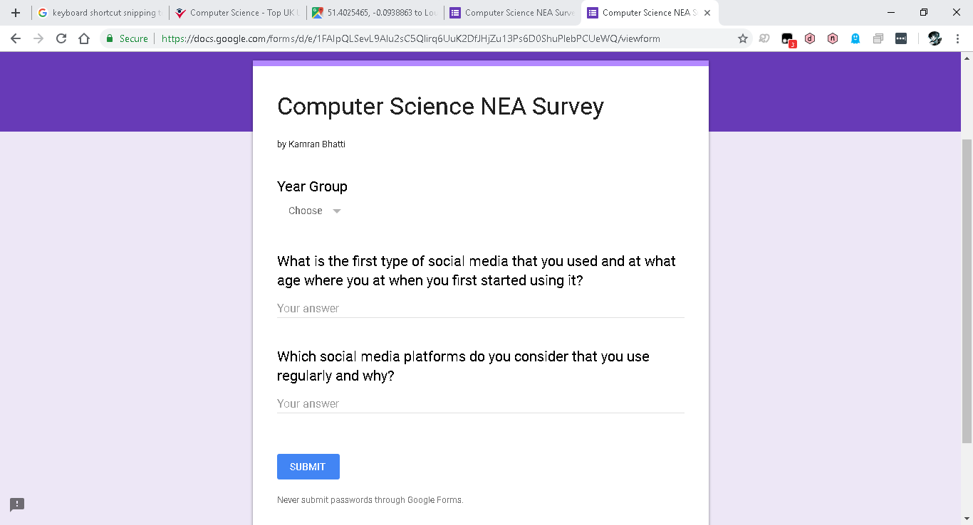

<https://goo.gl/forms/QifKvKvNWHI9oj7p2>

Questionnaire 1 in a word document

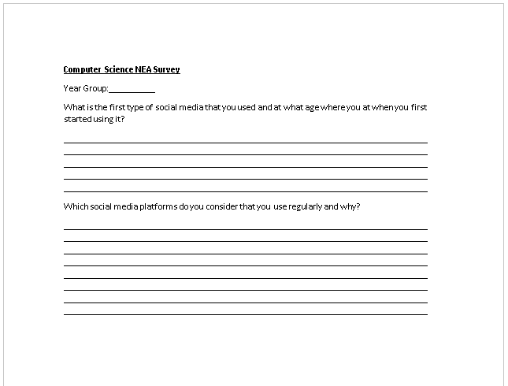

I phrased my second question in a way that would make participants consider what they “use regularly” as a form of social media seeing as my targeted audience for the survey predominantly uses multiple instances of social media in nearly every aspect of their day. The notion of “regularly” would make participants delve into discerning which platforms and types of platforms they frequent and the appeal these platforms have.

Questionnaire 2 in Google forms

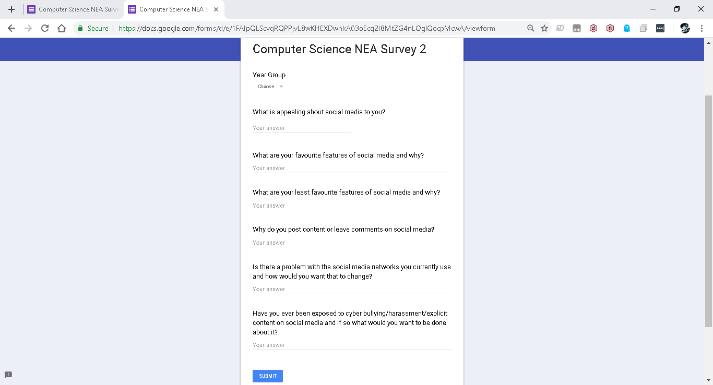

<https://goo.gl/forms/HjwMVsgAOJ6ZDaHz1>

Questionnaire 2 in a word document

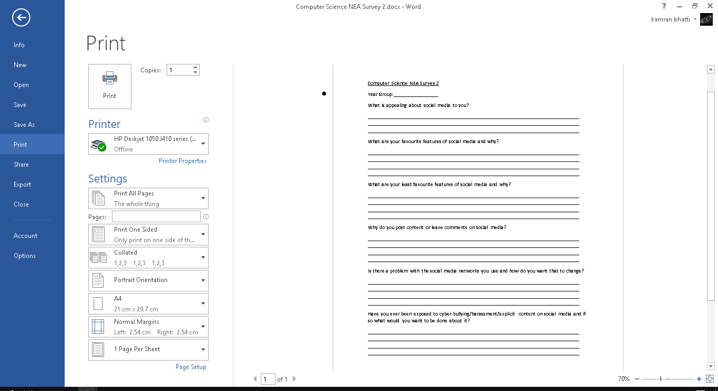

Using a multitude of data collection methods from surveys and interviews to online resources, I was able to scrutinise any opinionated sections where I discussed the problems background against realistic figures as depicted below.

Researching into the problem

* **“the exposure of children to profanity in social media has [caused] them to develop aggressive tendencies”**

A paper written by Adam G. Zimmerman under the University of North Florida states:

*“The increase in inappropriate or uncharacteristic behaviours while online has been called cyber disinhibition [which] occurs mainly because of the anonymous nature of the internet. Individuals may behave in ways that contradict normative behaviour when they do not identify with a particular online community and are free to leave without desire to return (Eastwick & Gardner, 2009).*

*[Individuals] are able to freely make any statements [or] even be whoever they want to be – only to simply ―log off at the end of the day. This ability to disconnect might trump the need for permission to behave in certain ways.*

*This extreme sense of freedom and ability to disengage with the click of a mouse might lead one to behave drastically different in comparison to [a face to face] interaction where this radical sovereignty does not exist.”*

I believe that this is a vital point; students may partake in cyberbullying or developing an aggressive behaviour as they are not limited by the constraints that are faced in the real world such as the repercussions of their actions. The notion of anonymity allows students to behave in a way that ‘contradicts normative behaviour’ as they are able to disengage emotionally from their actions.

According to the Daily Cougar in 2018:

*“Joseph Grenny, co-author of New York Times’ best-seller “Crucial Conversations” and Forbes contributor, did a study in 2013 that showed 78 percent of users reported a rise in hostility on social media and two in five people blocking, unsubscribing or unfriending someone due to a virtual argument.*

*In May [2018], two Pennsylvania teenagers, 18-year-old Kayla VanWert and 16-year-old Cathleen Boyer, started a feud on Facebook. The two arranged to meet in an alley where Boyer fatally stabbed VanWert in the neck.”*

This further reinforces the notion of students nurturing aggressive tendencies within their behaviour as the exposure to cyberbullies or harassment could lead to real life repercussions.

* **“[The use of social media] has caused academic hindrances.”**
* **“[Students] are not monitored when on their digital devices, thus causing students to give into temptation and peruse the internet for the latest gossip causing their studies to be neglected.”**

In a research paper written by Kolan John Bernard and Patience Emefa Dzandza under the University of Nebraska – Lincoln states:

*“It is also important to note that a total percentage of (31.5%) students responded that they did not experience any improvement in their grades”*

Furthermore, a paper written by Ezekiel S. Asemah and Ruth A. Okpanachi from Kogi State University and Leo O.N. Edegoh from Anambra State University dictates:

*“Items in table 4 [depicted below] show that social media [has a] negative influence on the academic performance of the undergraduate students of Kogi State University students. Students who spend more time on social media are likely to perform poorly in their academics.* 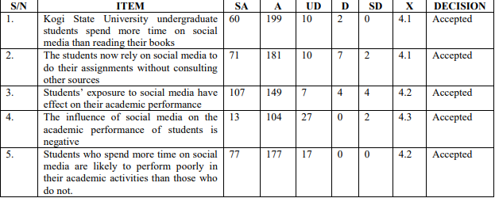

*It can be concluded that the exposure to social media by undergraduate students of Kogi State University students is high and this has negative effect on their performance.”*

This instils the notion that students are using social media to the point where their performance academically is affected adversely.

Oberiri Destiny Apuke states in a research articles written under Taraba State University that:

*“Majority of the respondents 75 (75%) strongly agreed that the influence of social media on the academic performance of students is negative, 10 (10%) agreed that the influence of social media on the academic performance of students is negative [whereas], 10 (10%) disagreed that the influence of social media on the academic performance of students is negative, while 5 (5%) strongly disagreed that the influence of social media on the academic performance of students is negative. This implies that to a very large extent [that] social media [has a] negative influence on [students’] academic performance.”*

These findings suggest that students are influenced heavily by social media. As well as reinforcing to me that an educational application of social media may be effective, I believe this expresses how students would benefit in using social media. Many ‘respondents’ consider that there are adverse effects to using social media when in regard to academic performance however, if the social media network was developed with educational prospects in mind it may allow students to spend time equally on digital and educational aspects of their lives.

* **“Students who use social media devote a large portion of their time digesting the latest trends or gossip that was circulating at the time due to having all of this information accessible from the click of a button.”**

In a clinical report written by Gwenn Schurgin O’Keeffe, MD, Kathleen Clarke-Pearson, MD, and COUNCIL ON COMMUNICATIONS AND MEDIA under the American Academy of Paediatrics it is stated that:

*“According to a recent poll, 22% of teenagers log on to their favourite social media site more than 10 times a day, and more than half of adolescents log on to a social media site more than once a day.”*

A paper written by Kolan John Bernard and Patience Emefa Dzandza under the University of Nebraska – Lincoln dictates:

*“Wiley and Sisson (2006), for instance argue that previous studies have found that more than 90% percent of tertiary school students use social networks. It is also found out that, students use social networking sites (SNSs) approximately thirty (30) minutes throughout the day as part of their daily routine life (Nicole, Charles, and Cliff, 2007). With regards to time spent on so social media, out of the 197 participants; 17participants (8.6%) spent between 0 to 30 minutes, 31 (15.7%) spent 30 minutes to one hour, 50(25.4%) spent 1 hour to 2 hours and 99 (50.3%) spent 2 hours and above. It can be deduced that majority of the students; (50.3%) spent over two (2) hours on social media on a daily basis”*

In an inquiry report written by Alex Chalk, Sarah Brennan and Matthew Reed, it is stated that:

*“Our survey indicated that nearly half (44%) of children and young people spend more than three hours per day on social media, whilst almost 1 in 10 (9%) reported always using social media overnight between midnight and 6am.”*

Additionally, in a research article written by Khurana N from Amity University published in December of 2015 states that:

*“In order to know about the kind of information the youth usually derives from these [social media], 37% responded to updates from family/friends, 31% [use these] sites as a source of entertainment, 23% derived information about general awareness and only 9% [use] them as a source of job related information. This in a way keeps them connected [to their friends and family] but simultaneously leads to a loss of focus towards their own goals, since only a small proportion of the youth seeks interest in gathering relevant information pertaining to jobs and general awareness (Figure 3)[depicted below].”*

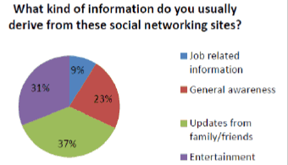

This suggests that students frequent social media greatly throughout the day. Equipping students with an application of social media that is monitored by an educational institution would allow students to not only access the neccesary aspects of social media but would also allow students to devote some of their time not only to social media but to their education.

* **“Students become consumed by their need to maintain their digital presence rather than how they choose to be represented in real life [as their education] is not as intriguing or emotionally stimulating.”**
* **“This correlation leads to students who frequent social media to attain lower grades than their counterparts.”**

A paper written by Kolan John Bernard and Patience Emefa Dzandza under the University of Nebraska – Lincoln states:

*“The study conducted by Owusu and Agatha (2015), titled “use of social media and its impacts on academic performance of tertiary students” revealed that [the] majority of students in Ghana were engrossed in social networking sites. It also brought to light that most users utilized these sites for chatting and downloading purposes only which affected their academic performance negatively.*

*[Most] respondents in their study experienced negative effects such as poor grammar [,] spelling, late submission of assignments, less study time and poor academic performance.”*

Furthermore, in a clinical report written by Gwenn Schurgin O’Keeffe, MD, Kathleen Clarke-Pearson, MD, and COUNCIL ON COMMUNICATIONS AND MEDIA under the American Academy of Paediatrics it is stated that:

*“Seventy-five percent of teenagers now own cell phones, and 25% use them for social media, 54% use them for texting, and 24% use them for instant messaging. Thus, a large part of this generation’s social and emotional development is occurring while on the Internet and on cell phones.”*

* **“[Students] may encounter forms of cyber bullying which could cultivate self-harming, having suicidal thoughts or isolating themselves both in reality and virtually.”**

Written in an article by the American College of Obstetricians and Gynaecologists:

*“According to one study, 20–40% of adolescents report having been victims of cyberbullying**. Traditional bullying and cyberbullying are associated with increased anxiety, depression, and low self-esteem in adolescents**. Bullying also has been associated with other physical health effects, including stomach-aches, sleep problems, headaches, tension, bed-wetting, fatigue, and poor appetite**. A meta-analysis of 33 studies concluded that being a victim of bullying is a risk factor for lower grades and standardized test scores**. More recent studies have shown that bullying is associated with increased substance use, violent behaviour, unsafe sexual behaviour, suicidal behaviour, and likelihood to carry a weapon.”*

In an article written by the Department of Health from the Government of Western Australia, it is stated that:

*“Every 7 seconds someone in the world is cyberbullied. Approximately 50% of victims know their perpetrator (usually another student at same school). Approximately 50% of victims met their perpetrator online and did not know them.”*

An inquiry report written by Alex Chalk, Sarah Brennan and Matthew Reed, states that:

*“Thirty eight percent of young people reported that social media has a negative impact on how they feel about themselves, compared to 23% who reported that it has a positive impact. This was exacerbated for girls, with 46% of girls stating that social media had a negative impact on their self-esteem.*

*83% of young people [said] that social media companies should do more to tackle cyberbullying on their platforms.*

*Eighty two percent of young people thought social media companies should do more to promote mental health.”*

In a review from the MMA (Mahwah Municipal Alliance), the following figures are proposed:

*“83% of victims felt that bullying hurt their self-esteem. 30% of children who have been bullied have suicidal thoughts. 10% of children have attempted to take their own lives due to bullying. 19% of cyberbullying entails the spreading of rumours. 72% of children report they are cyberbullied because of their looks. 26% of victims are chosen due to their race or religion. 87% of today’s youth have witnessed cyberbullying. 24% of children do not know what to do when they are harassed. 39% of our children do not enable privacy setting on social media.”*

I believe that this is in imperative reason as to why there should be a platform of social media which is monitored by an educational institution. Many students are exposed to cyber bullying which cultivates feelings of aggression, anxiety and hurts students’ self-esteem. With an application of social media that is monitored by a school, cyberbullying can be prevented and actions can be taken to help students who need assistance or guidance when dealing with bullying or exposure to harassment.

From an article in the Guardian, it is proposed that:

*“[In] a McAfee poll of 11- to 17-year-olds in 2014, 35% reported that they have experienced cyberbullying, up from 16% the year before. Another organisation found that Google searches for “cyberbullying” surge at the start of the school year.”*

It is stated on an article on Bullying UK that:

*“20% of children and young people indicate fear of cyber bullies made them reluctant to go to school. 5% reported self-harm. 3% reported an attempt of suicide as a direct result of cyber bullying. 28% of young people have reported incidents of cyber bullying on Twitter. 26% of young people have reported incidents of cyber bullying on Ask.fm.”*

In a research paper written under the University of California Institute for Prediction Technology by Renee Garett, Lynwood R. Lord and Sean D. Young it is stated that:

*“In the United States, a majority of students aged 12 to 18 reported that they were cyberbullied at least twice during the past year.”*

* **“[Students] may adopt the notion that they are unable to access avenues which could provide them the guidance or help they need.”**
* **“[The] greatest threat these students face is their own naivety; from succumbing to peer pressure by posting unfavourable content to being coerced into sharing explicit images.”**

In an article written by Kelly Wallace from CNN, it states that:

*“More than half the undergraduate students who took part in an anonymous online survey said they sexted when they were teenagers, according to the study by Drexel University, which was published in June by the Journal of Sexuality Research and Social Policy.*

*Nearly 30% said they included photos in their sexts, and an astonishing 61% did not know that sending nude photos via text could be considered child pornography.*

*92% of the teens who said they were not pressured to sext reported no problems afterward, but that number is only 68% for teens who felt pressured into doing it.”*

In an article written by the Department of Health from the Government of Western Australia, it is stated that:

*“Research indicates that 1 in 5 young people (8-17 years old) have experienced cyberbullying, however, research shows students often don’t tell an adult. They fear we will disconnect them from supportive friends and family and may overreact and make the situation worse.”*

In a report prepared for the NSPCC written by Jessica Ringrose (Institute of Education, London), Rosalind Gill (King’s College, London), Sonia Livingstone (London School of Economics) and Laura Harvey (Open University) the following figures are presented:

*“12% of 11–16 year olds in the UK have seen[/]received sexual messages online, 2% receiving them more than once a week (compared with 15% receiving them across Europe). Girls are slightly more likely to have received them than boys (14% vs. 10%), and 11–12 year olds are less likely to receive sexual messages online than the older age groups (5%, vs. 20% of 15–16 year olds). Posting/sending sexual messages is even less common than seeing/receiving them [,] 4% of 11–16 year olds say that they have done this online in the past 12 months. Overall, 3% of 11–16 year olds in the UK said they had seen other people perform sexual acts in online messages, 2% had been asked online for an image of their genitals, and 2% had been asked to talk about sexual acts with someone online. Of the 12% who had received some kind of sexual message, one quarter of those had been bothered or upset by this (more often younger children), the remainder reporting no harm from such messages. Among those (across Europe) who had been bothered by ‘sexting’, about four in ten blocked the person who sent the messages (40%) and/or deleted the unwanted sexual messages (38%); four in ten children did not tell anyone [even though] they had been bothered by the experience.*

*[In a survey among 11-18 year olds it was] found that 40% say they know friends who share sexual images (via any electronic means) and 27% say it happens regularly or all the time. Half knew of cases where sexual messages had been circulated beyond the originally intended recipient (and half of those thought the intention was to cause distress) and 30% knew someone who had been adversely affected by sexting (10% had themselves been affected; Phippen, 2009).*

*[From] a nationally representative sample of US mobile phone owners aged 12–17 years [found] that 15 % had received sexually suggestive, nude, or near nude images of someone they knew via text messaging on their cell phone, and 4% had sent such messages (Lenhart, 2009). In their 2011 update [Pew Internet] found little change two years on – 2% of all teenagers have sent a ‘sexually suggestive nude or nearly nude photo or video’ of themselves to someone else, while 16% (more older than younger) have received a sexually suggestive nude or nearly nude photo or video of someone else they know.”*

This reaffirms how students should be monitored when using forms of social media. This displays how students are coerced from either receiving explicit images or feeling pressured into sharing explicit images to which puts students in an unsafe online environment in which they may feel uncomfortable or unable to cope with the situation at hand.

Furthermore, written in an article by the American College of Obstetricians and Gynaecologists:

*“A 2008 survey showed that 19% of females (aged 13–19 years) and 32% of women (aged 20–26 years) had sent nude or semi-nude pictures, and 31% of the former group and 46% of the latter group had received such pictures.”*

Interviews

In order to test the adverse effects of social media in a school setting I conducted interviews with a boy and girl from each year group, from Year 7 to Year 13 as most of the research I conducted into the background of the problem had found that most figures for the effects of social media had effected age ranges between 11 and 18 years old.

Amongst this group of individuals, all participates had agreed that they have used a form of social media either recently or in the past week.

All interviewees quickly agreed that they had experienced a form of harassment on social media in the past but when asked about aggression towards being harassed, 5 of the 7 boy’s and 3 of the 7 girl’s answers were generally similar in stating:

*“It is annoying to the point where I feel like my head is going to explode.”*

Whereas the remaining answered similarly in saying that:

*“It is bothersome but it’s just words. They are just people trying to get a reaction.”*

Although the last statement depicts how there are students who do not display any aggression towards being harassed as they feel it is just a ploy instilled to evoke a reaction, here it’s evident that all participants had experienced harassment in one form or another. However, this also indicates that students feel a form of aggression towards being harassed which may have a greater influence on boys considering the majority of them responded emotively in stating that they “feel like [their] head is going to explode” which is also shared among some of the girls showing that they also adopt this form of aggression.

Furthermore, I proceeded to ask how long students tend to spend on social media during the week. Interviewees responded differently depending on Year group.

Students from Year 11 and 13 answered with 2-5 hours per week.

Year 7 and 8 students answered with 12-15 hours per week.

Year 9 and 10 students answered with 10 hours per week.

Year 12 students answered with 5-7 hours per week.

This seems relatively similar to my expectations as I expect students in Year 11 and 13 to have less free time due to exam preparation and work load. Year 12 have more free time than Year 11 or 13 as they don’t have to prepare for examinations thus allowing them time to peruse the internet at their leisure in their free time. Surprisingly, students in Year 7 to 10 spend more than 9 hours per week using social media which could supplement as to why students are attaining low grades due to perusing the internet for a large amount of time to which they neglect their studies.

I proceeded to ask if the students had ever experienced cyber bullying.

Students in Year 7 and 8 quickly answered by saying:

“No I haven’t”

From Year 9 to 13 there were mixed responses. 3of the 5 remaining boys stated that they had experienced cyberbullying whereas 2 of the 5 remaining girls agreed in stating:

“I have in the past but not anymore”

Whereas the remaining participants shared the views of the Year 7 and 8’s. It was surprising to see that no Year 7 or 8 students had experienced cyber bullying however, it is shown by my findings that cyberbullying although not prevalent, still exists in a school setting as depicted by 5 students experiencing a form of cyber bullying while attending the institution. As my findings are coming from a small sample of the school this number may be skewed in which more students may be experiencing cyberbullying than depicted within my findings which further supports the need for an establishment like a school having a social media platform where they can monitor cyber bullying.

Lastly, I asked if any of the interviewees had sent or received explicit content through social media.

The Year 7 to 9 students stated that they hadn’t received or sent explicit content through social media.

From Year 10 to 13 I received a mixture of responses. Half remaining boys said they had sent explicit content through social media and half said they received explicit content through social media. 1 of the remaining girls said they had sent explicit content through social media however, 3 of the 4 girls said they had received explicit content through social media. This suggests that the higher Year groups within the institution have been exposed to explicit content through social media or have shared explicit content through social media.

Overall, I believe that these interviews supplement to how detrimental social media can be to students in an educational institution in consideration to how students are exposed to cyberbullying, harassment and explicit content to how students frequent social media to the point where their academic performance is severely neglected. This shows that unmonitored exposure to social media can be detrimental to a student’s academic development. I believe that there is room to improve the current application of social media to incorporate techniques to improve safe guarding on the platform. This could reduce exposure to cyberbullying or explicit content which could also encourage students to devote more time to their education and studies outside of school as this age group uses social media to the point where they experience academic deficits.

Feedback from questionnaire 1

For some of the questionnaires I converted the data collected to pie chart form as to show the data in a way that could easily be understood.

Year Group:

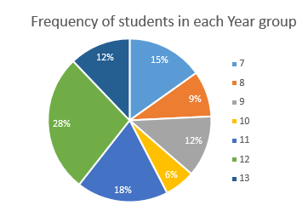

This shows that of the 33 students that I interviewed and had given questionnaires to, the majority of students who participated were in Year 7, 9, 11, 12 and 13.

The students from Year 12 stated that they started using social media from as early as 5 with platforms like YouTube to the age of 14 with platforms like WhatsApp, Facebook and Snapchat as shown below:

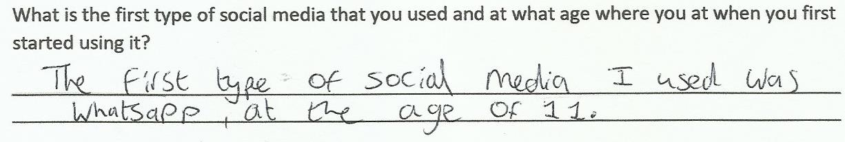

For Year 13 students, it was conclusive that these students started using social media as early as 12 or 13 with Facebook.

The data retrieved from Year 7 to Year 11 student however were very interesting considering that the Year 11 students stated that they had started using social media from the age of 12 but with the Year 9 and 10 students stating that they started using social media at the age of 10 and that the Years lower started using social media platforms from the age of 7.

I believe that this clearly shows how the advancement of technology has allowed students to be exposed to social networks from a starting age which depreciates as the years go on.

When asked what networks students use regularly and what seems to be appealing about these networks, the results were skewed towards Snapchat and Instagram as shown below:

Number of students using each platform:

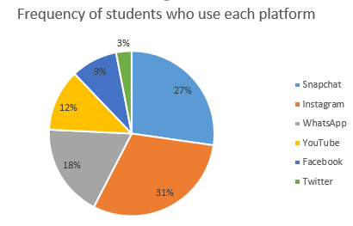

This depicts that most of the 33 students who participated are using Snapchat or Instagram compared to other social media platforms. When questioned on why students use these platforms the students responded by saying that they used the platform to interact and stay in touch with friends and family members however, the spread of data shows that most students use other forms of social media as well as Snapchat and Instagram. This is depicted below:

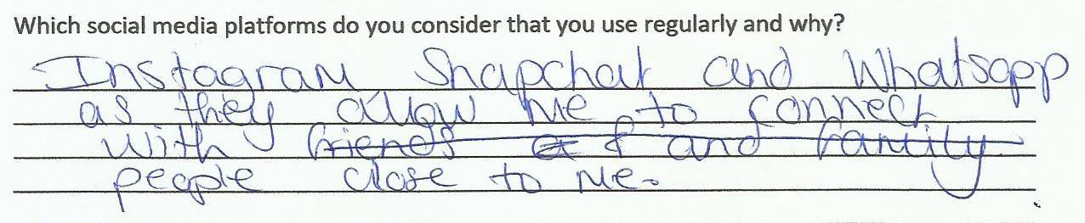

However, the only platforms which are suitable for this age group being in secondary school in YouTube and WhatsApp and considering that the frequency of students using social media platforms other than these is quite large show that there is a need for a system to be instilled to monitor the content that students have access to on social media as although the age requirement for these platforms are clearly stated when signing up, students disregard these warnings and continue to use the platform anyway.

Feedback from questionnaire 2

With the same group of students I continued to hand out my second questionnaire.

What is appealing about social media?

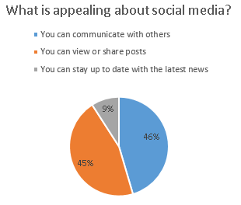

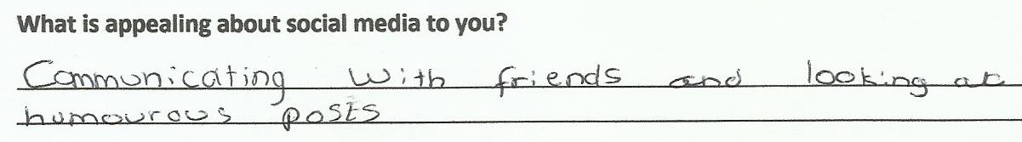

As shown most responses align with the idea that you can communicate with others and being able to view of share posts while a small majority use the social network to stay up to date with current affairs.

What are your favourite features of social media?

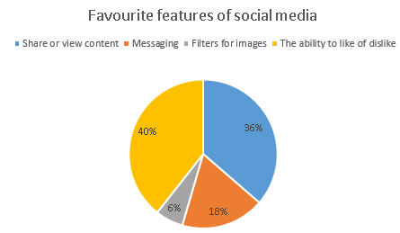

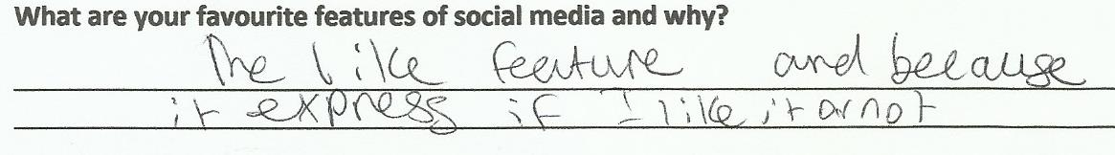

This depicts that the majority of students use social media with the intent to share or view content and because they are able to express if they like or dislike content on the platform so that the content creator is able to supply more content to the user. However, a considerable amount of users use social media to message others and to create filters when taking images.

What are your least favourite features of social media?

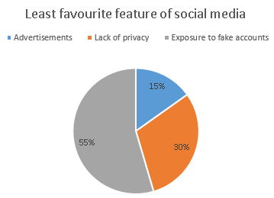

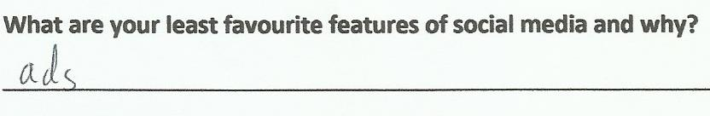

This depicts that a considerable number of students find that advertisements are their least likeable feature of social media and when asked why, students tended to state that it takes away from the experience when interacting with the social media platforms. However, surprisingly when considering the majority response was the lack of privacy and exposure to fake accounts; when asked why students found this feature to be least favourable the response was very similar in stating that you could be exposed to dangerous people or that you can be exposed to abusive or slanderous content.

When asked why students post content or leave comments of social media the response was very similar in stating that they want to be able to share their opinion on a post or so that they are able to express themselves by sharing what they are doing with others.

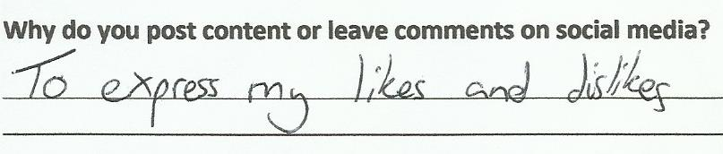

Additionally, when asked if there is a problem with social media networks that the students use and how they want them to change, I received a variety of vague responses which tend to align with a single commonality. Either the service they are using is burdened with needless features which renders the service unfavourable such as being exposed to advertisements when on the service or, students stated that they felt that cyberbullying and exposure to predators on the internet is the main problem as these individuals are able to hide behind the anonymity of the network. When asked how they want this to change students stated that they want more precautions put into place to ensure the safety of the users on the platform and that needless features should be removed from the platform to ensure that the platform is user friendly.

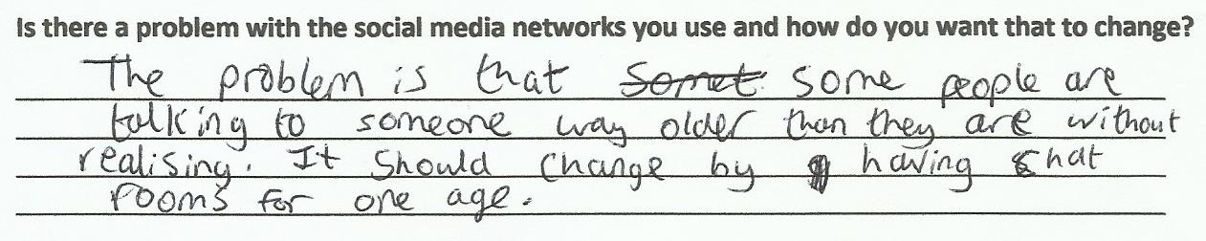

Finally, when asked if students had been exposed to either cyber bullying, harassment or explicit content through social media and what they would want to change to ensure that it doesn’t happen in the future, the responses I received were very similar. Students responded by saying that when dealing with cyberbullying, harassment or explicit content, they want the content to be disposed of swiftly and that they want the administrators of the network to get into contact with the individuals who are affected. 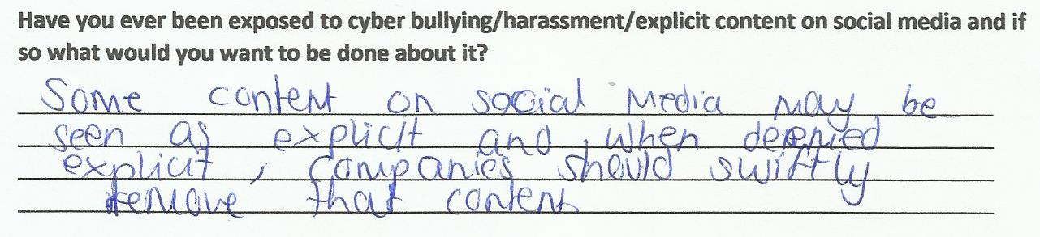

Conclusions

From the initial survey I can conclude that my target audience for my project should be for students in secondary school. This is evidenced by students in secondary school stating that they started using platforms like Snapchat, Facebook and Instagram from as young as 12 which is significantly younger than the age that is specified on the terms of service for users of the platform. Furthermore, as students are using services from such as young age I will be creating a project which aims to improve safe guarding and reduce exposure of young adolescents to inappropriate content via social media.

From the second survey use social media platforms to communicate with others and to share or view posts. I can also infer that students want to use a platform which has some form of like or dislike feature as it allows users to convey to content creators or posters their preferences on what they decide to share with others. Furthermore, I also acknowledge that advertisements on social media networks can be intrusive and unpleasant when using the platform for long sessions however, the greater issue which was raised was the exposure to fake accounts and lack of privacy. This further reinforces my proposal to create a platform which ensure the safety of students online when on social media.

Therefore, I will be incorporating like or dislike features into my platform as well as implementing a system to block and report users of the service as to ensure the safety of users and to reduce the exposure of students to cyberbullying, harassment and explicit or vulgar content.

Current system

The current system refers to the application of social media which is generally used today.

One example would be Facebook. As of September 2018, Facebook has **2.23 billion** monthly active users.

Facebook

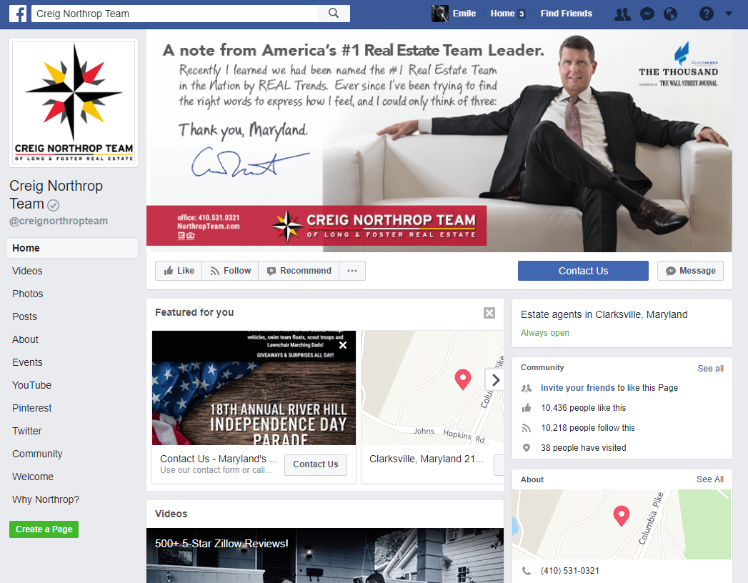

Facebook is a social media platform which is generally used to promote businesses or to stay in touch with peers or colleagues. The features of Facebook is that you can create a profile to advertise your business or your own personal profile, to create posts to show your friends, to stay in touch with friends, share videos and photos on the internet and to read the news or online articles. You are also able to direct message and group message individuals on the network. Additionally you are able to comment on people’s posts and share their posts with others. You are able to report, block individuals and remove friends on the platform as well as instant message individuals. However, there is no profanity filter in place and there is no way to stop explicit content being sent to you or a way to stop cyberbullying.

Furthermore, the settings to ensure that the content you post on your profile is only visible to you or friends and not from the public is difficult to find and there is a lack of safeguarding or awareness that adolescence use the network which entails in students being exposed to inappropriate content. This may lead to students being susceptible to stalkers from their posts being used to locate them

Another example of a popular social media platform would be Twitter. As of September 2018 there are **335 million** monthly active users of the service.

Twitter

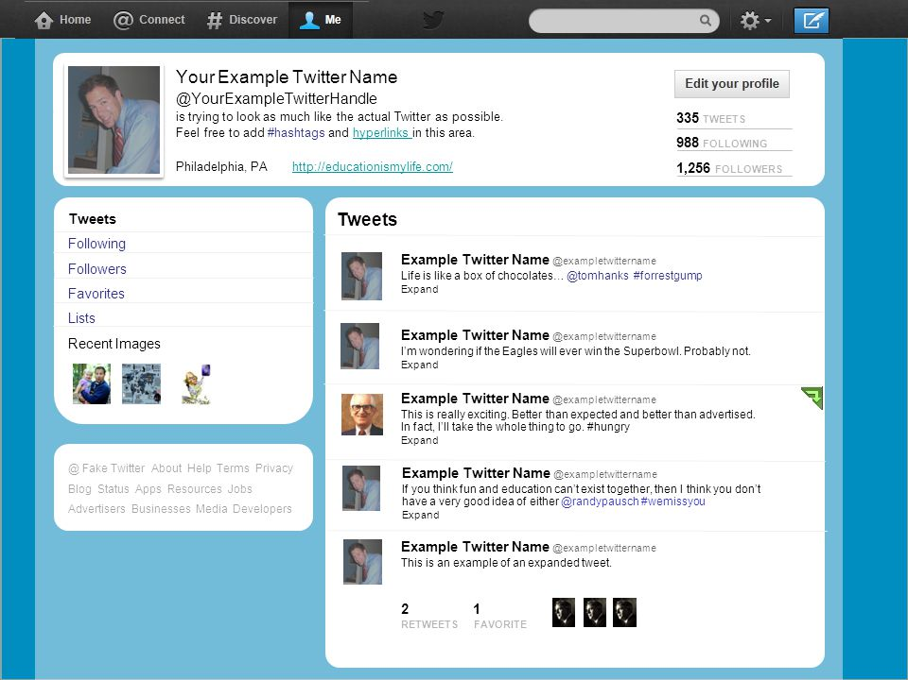

Twitter is a social media platform that is used as a micro-blogging service to post short posts called “Tweets” which are viewable by followers which allow you to convey what you do throughout the day. The main features of Twitter is that you can follow people to view their twitter posts regularly, you can post images or video, you can create a profile and you can repost what someone has posted before and comment on someone’s post or share their post with others. You are also able to unfollow accounts so that you don’t see their posts anymore and you are also able to block or report accounts on the platform. There is also a profanity filter in place which stops users from viewing content with any profane language which can be turned on in settings. However, there is no way to avoid exposure to explicit content in the form of images of video and there is no system to confront cyberbullying besides reporting an account which freezes the accounts activity. Furthermore, the site is limiting in functionality considering that you are only able to post content within 282 characters.

Additionally, there is a social media platform called WhatsApp. As of September 2018 there are 1.5 billion user and 60 billion messages sent per day which has increased in comparison to 1.3 billion monthly users and 1 billion daily active users in July 2018.

WhatsApp

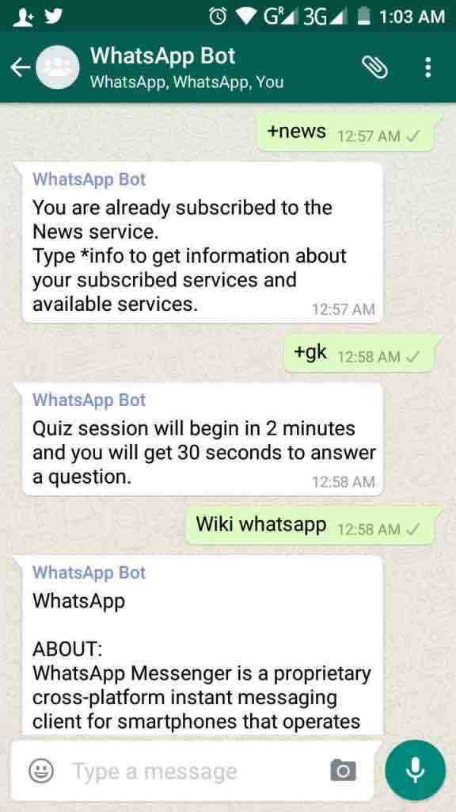

WhatsApp is a social media platform for smartphone devices. It is primarily an instant messaging app that allows multimedia to be shared which includes photos, video, audio and documents. It includes video calling with high quality streaming. You are able to direct message and group message individuals. There is no way to filter profanity from the app and there is no way to report users of the app so that their account gets frozen but you can block users like a traditional messaging service.

Furthermore there is a social media platform called Instagram. As of September 2018 there are 1 billion monthly active users with is up from 800 million in September of 2017.

Instagram

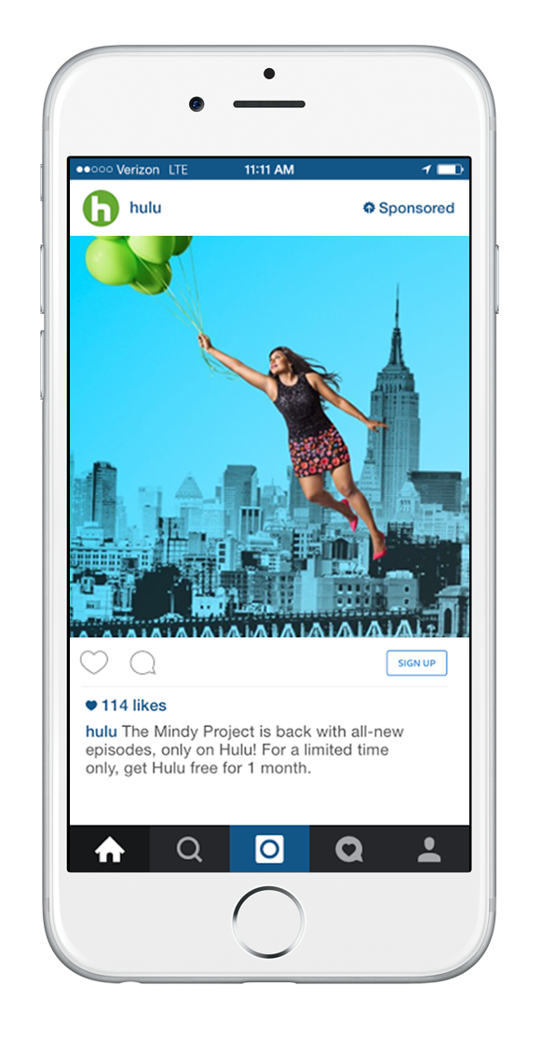

Instagram is a social media platform which was first designed for smartphones and then released for use in internet browsers. One feature of Instagram is that you’re able to watch individuals’ stories which they upload. It is either a video or images which disappear after a day. You can also create stories of your own. There is also Instagram videos which are videos which are made by an individual and are stored thus not being erased after a day. You can like pictures, comment on pictures, share pictures and follow people to view what they post. You are able to block and report people in which their accounts’ activity is frozen until it is reviewed. There is no profanity filter of way to filter explicit content. You are also able to instant message individuals on the service.

Another social media platform is YouTube. As of September 2018 there are 1.8 billion users who use YouTube every month.

YouTube

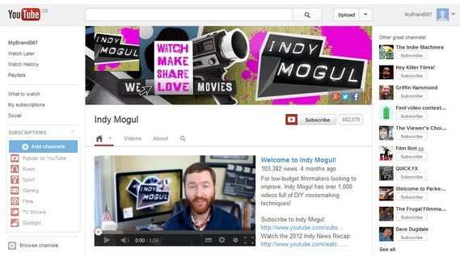

YouTube is a video networking site which is made by Google. It is available for both smartphone and website use. You are able to watch movies, TV shows, listen to music, cartoons as well as private videos, blog, YouTube original shows and videos made by content creators on the site. You are also able to create an account to upload videos to your channel, earn money from advertising on your video when viewers watch your videos and you are able to follow channels to stay up to date with the latest content that these individual channels produce. You are also able to take part in polls held by certain channels, watch live streaming video from content creators, leave comments on videos and you are able to save videos to watch later or download videos to watch without an internet connection. You are able to report content or a comment for being explicit or if the content is rude in anyway. You are also able to like to dislike content and comments to show appreciation for the content or comment and you are able to reply to comments that users make on a video. Additionally you are able to support a channel by donating funds to the channel. Furthermore, there is a profanity filter however it is in the form of a separate platform called YouTube kids in which there is no explicit content or profanity but for the normal YouTube platform there is no profanity filter.

There is also a platform called LinkedIn. As of September 2018 there are 500 million users of its business-focused network which is up from 467 million from October 2016.

LinkedIn

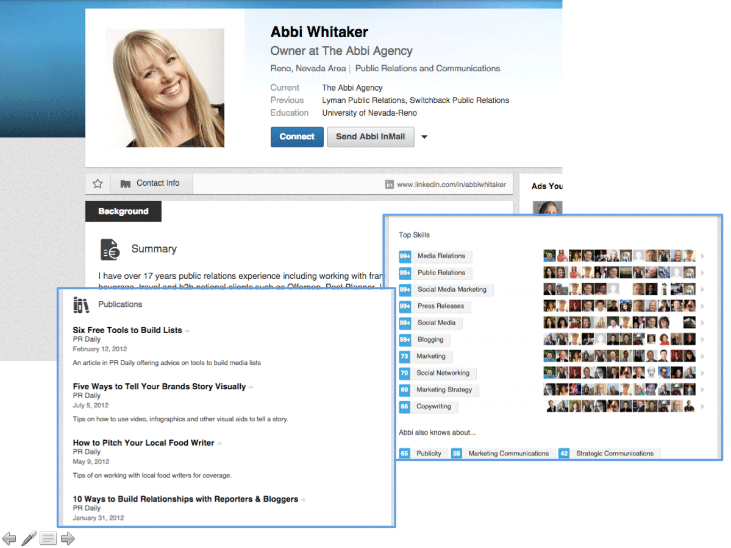

LinkedIn is a site for working professionals and business personnel. You can make a public portfolio or resume by updating your profile which you can fill with your qualifications, school attended, people you may know and any previous experience in the world of work. This social media platform is generally used in means of finding jobs as well as employees by connecting professionals with mutual interest. This platform also allows individuals to promote businesses and advertisements for positions in their establishment. You are able to block or report individuals however there is no profanity filter as this social media platform is generally targeted at individuals seeking a job so it is not aimed at school students.

Another example would be Pinterest. As of September 2017, the platform had reached 200 million monthly active users which is up from 150 million in October 2016.

Pinterest



Pinterest is a similar social media platform to Instagram considering that it is a social media platform based on the sharing and posting of images. Its interface severely differs from Instagram and its main purpose is to act like a gallery or archive of images. If you find an image you like you’re able to save it and view it later and you are also able to post your own images. Additionally there are features incorporated to block users or report users if they post inappropriate content on the site however, as of September 2018 there is no implemented feature to filter profanity from the website besides reporting inappropriate content.

Another example of a social media platform would be Tumblr. As of May 2013, there has been an estimated 30-50 million monthly users of the service which has dropped significantly from 300 million monthly users.

Tumblr

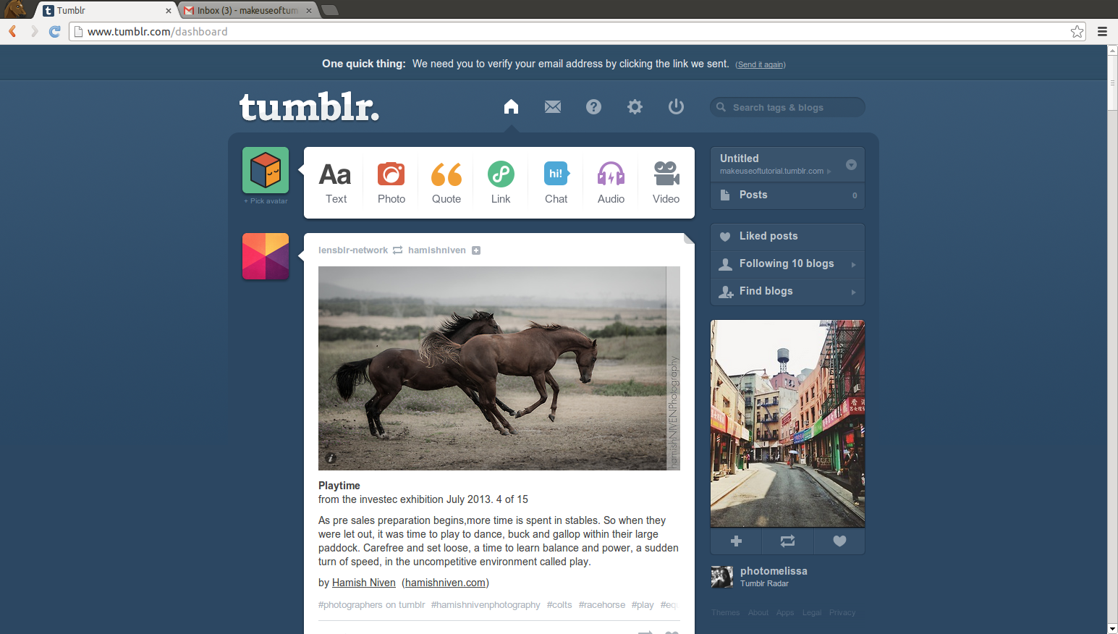

The network is used as a social blogging platform. You are able to use the site socialize with others and use the site as a way to document the users life experiences such as in the form of a travel blog, photo blog, a blog to advertise their interest in a certain hobby or pastime or as a way to advertise a business. Additionally, you are able to message individuals on the platform with the feature to also be able to video chat individuals privately by accessing the service from a web browser or a smartphone. You are also given the functionality to like and dislike on Tumblr. Furthermore, you are able to block users on Tumblr whether they are friends or anonymous as to reduce exposure to harassment from users on the network. Whilst being given the feature to unfollow blogs on the platform you are also able to delete or block users who follow your blog with the additional feature of being able to report users for continued harassment or spam. Also, you are given the option to enable a profanity filter/content filter to ensure that you aren’t exposed to any explicit content whilst perusing the platform. However, this filter has to be manually turned on and is not turned on from initial use of the service thus students and children may be exposed to explicit content as they may be unaware that they haven’t enabled the feature.

Lastly, another popular social media network is snapchat. As of September 2018 there are 188 million daily active users of the service which is down from 191 million daily active users from January 2018.

Snapchat



The social media platform is for smartphones to share photos, videos, texts and drawings. The main feature of snapchat is that the messages a user sends disappear from the recipients’ phone after a few seconds if the message is not chosen to be saved. However, when sharing photos instantly after taking them in the application, the details of the send and the time stamp of when the photo was sent still remain. Users are able to add friends from their devices’ contact list in addition to adding friends who are nearby or by adding users by name or by adding an individual by their identification image colloquially referred to as ‘snap code’. You are also given the option to overlay text or drawings on photos of your choice. In addition to this, you are able to voice and video call individuals and leave audio/video notes using the messenger feature. You are also able to use augmented reality filters on images that you take. Similarly to Instagram stories, snapchat have their own feature which allows you to post images and videos which are viewable by anyone who is friends with you or by who you specify which last 24 hours before getting deleted. There is also a feature called snapchat memories which allow users to upload photos and video from their devices photo library. You are also able to group message individuals, find individuals on a map to show where your friends that you have added are in addition to being able to view public ‘stories’ which are made by news networks to keep users of the network informed on current affairs. Although you are able to block and report individuals on the service and stop individuals from being able to view what your posts or where you are located; as of September 2018 there is no profanity filter or a way to monitor explicit content which could be received from individuals as a shared photo which may contain abusive or explicit content.

Objectives

* Creation of website
  + Make website responsive in zooming in/out
  + Relevant buttons leading to individual pages
* Redirection when webpage button are clicked
  + Login to main page
  + Register to register information page
  + Logout to login page
* Store details of personal details of user
  + Username
  + Hash passwords of users
  + Date of birth
  + Year group
  + Postcode
  + Town
  + Interests
* Posts
  + Validate that content is present in post
  + Ensure users cant enter any explicit or profane content
  + Load multimedia
    - Check that file path exists on users computer
    - Displaying error message if multimedia file does not exist
  + Filter posts
    - By name/date/keywords
  + Store post information
    - Name of post/date posted/Name of user who posted content and store content
  + Delete posts from their account
* Comments
  + Ensure user cant post comment without content in field
  + Store name of user who commented and date of comment
* Creation of algorithm through graphs that will recommend friends to users by
  + Year group/common interests, postcode, town
* Ability to Add/remove friends
* Admin permissions
  + Filter posts
  + Delete posts of multiple users
* Table for each data store in a database
* Client server model to access social media network from anywhere with an internet connection.

Objectives added due to results from surveys

* Like and dislike functionality on posts
* Ability to block or report individuals

Initial Dataflow Diagram (DFD)

Dataflow diagrams portray how data flows through a system. In this instance I will be using data flow diagrams in means of depicting how data is used within an interactive website designed as a social media platform for the intention of being used within a school environment.

Context level DFD:

A context level DFD is a simple diagram that gives an overview of the general processes of the interactive website.

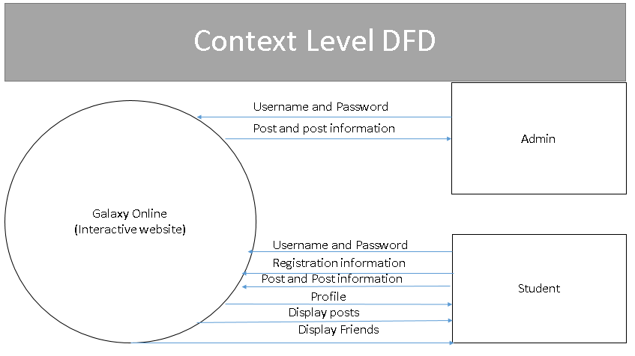Level 0 DFD:

A level 0 DFD is more detailed than the context level DFD as it shows how the data is used in the interactive website.

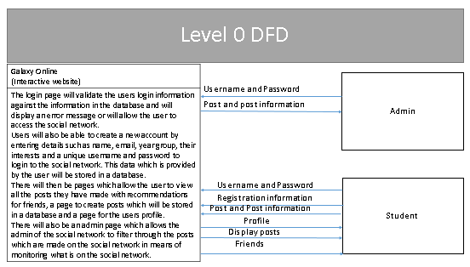

Level 1 DFD:

A level 1 DFD is even further detailed than the context level DFD or level 0 DFD by displaying each individual process that the interactive website will carry out and how data flows from the users of the interactive website to the data stores being accessed by each process respectively.

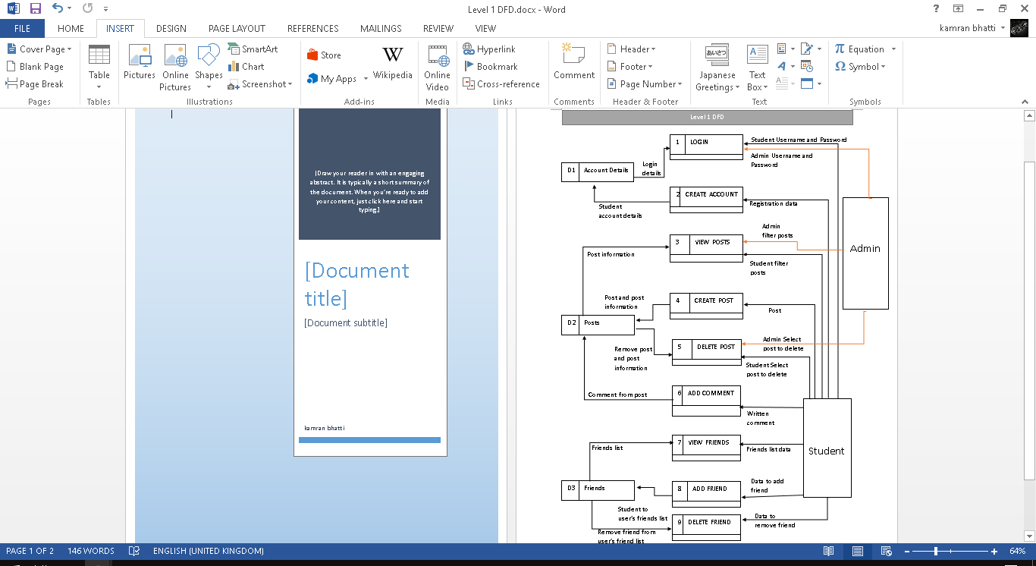

Overview of processes:

|  |  |  |
| --- | --- | --- |
| Process Number | Process Name | Description |
| 1 | LOGIN | When login details are entered these credentials are verified by checking the inputted details with the credentials already in the Account Details table. If the details match then a user is able to access the interactive website. If the details don’t match then the user is denied access and asked to re-enter the correct credentials. |
| 2 | CREATE ACCOUNT | Registration information will be entered here such as username, password, name, year group, date of birth or email address to create an account for the user and is stored in the table Account Details. |
| 3 | VIEW POSTS | A user will select post to view which will then access the Posts table which stores multiple posts and will display the relevant information associated with the post. |
| 4 | CREATE POSTS | A user will create a post that will be stored in the Posts table that will store the posters’ name and the relevant information like the posts file size, data type of the post, post description and when the post was created. |
| 5 | DELETE POSTS | A user or administrator will select a post to delete and then the post with its relevant information will be removed from the Posts table. |
| 6 | ADD COMMENT | A user will create a comment under a post therefore the publisher of comment, time comment was created and contents of comment would be stored in the Posts table. |
| 7 | VIEW FRIENDS | A student would select to view their personal friends list in which data would be pulled from the Friends table showing friends which the student has with relevant information like name and year group. |
| 8 | ADD FRIENDS | The student would select to add a friend thus the friends’ information would be stored as a friend relationship in the Friends table. |
| 9 | DELETE FRIENDS | The student wants to remove a friend thus when selected the friends’ information would be removed from having an association with the student from the Friends table. |

Initial Data Dictionary (how tables or data should work):

An initial data dictionary dictates how data is grouped and the purpose of the data being used in the interactive website.

|  |  |
| --- | --- |
| Name of Data | Purpose of data in the system |
| Username and password | This data will be used to allow users to securely access their social media profile. |
| Registration data | This data will contain the users’ full name, date of birth, year group and their selected username and password which will allow users to create an authenticated account. |
| Admin/Student filters post | This will contain post information such as name of creator, date created, the post, a description of the post if one is available and any comments associated with the post. |
| Admin/Student selects post to delete | This allows the Admin/Student to select posts to delete which will contain the information about the post (Admin being able to delete posts of multiple users whereas the student being able to delete only their personal posts) |
| Written comment | The comment would be attached to a post with the time/date at which the comment was created and the name of the student which created the comment along with the details of the comment. |
| Friends list data | This information will consist of friends that the student has which will display the name of the friend and the length of time of the friendship. |
| Data to add/remove friend | This will contain the name of the friend that will be removed/added. |

Gant chart:

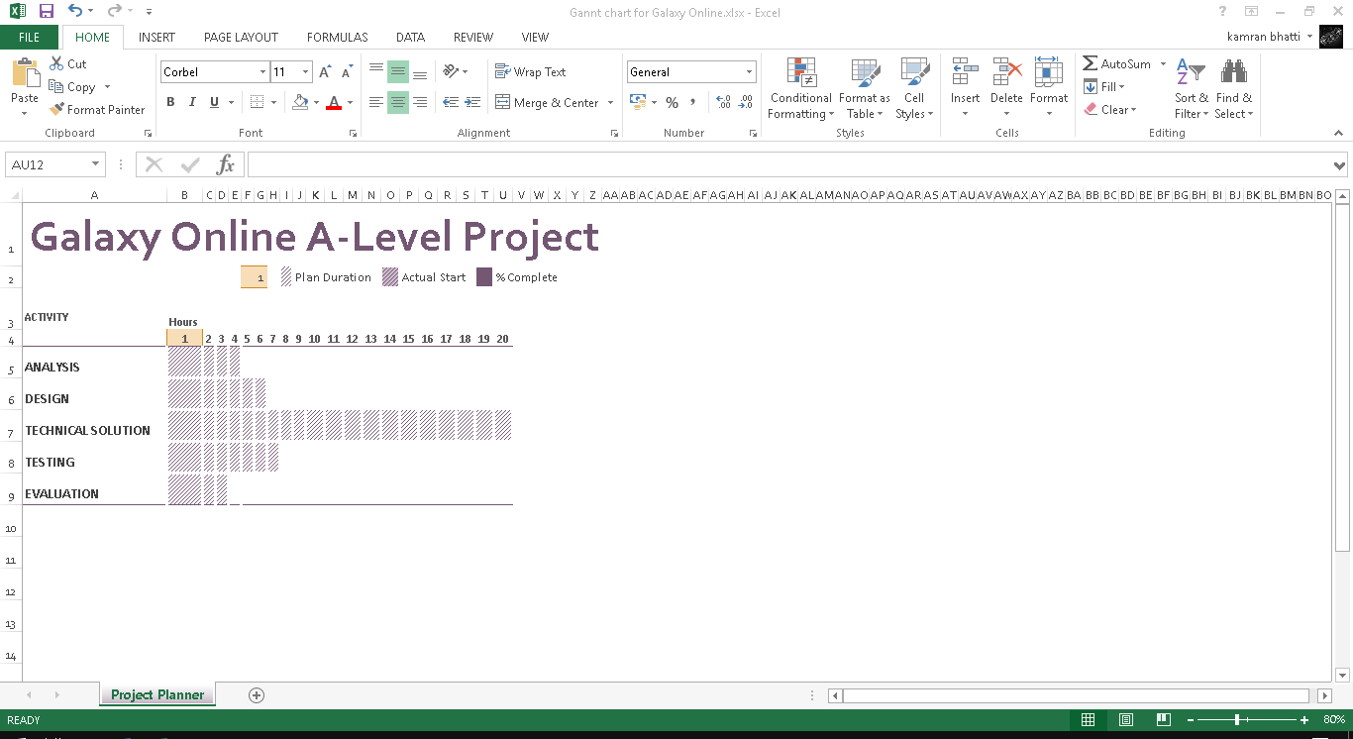

Observations (how the project should work)

Any additional research (if applicable) (what languages you would use. Why you use one over the other, how you would use the languages, features of each)

Proposed solution details (hardware/software requirements)

Project Limitations (Limitations agreed with end-user/supervisor) (financial limitations/time constraints)

~~Development Methodology used in project~~

Constraints of the project

**Evaluation**

To improve the project you could import google’s email verification api to ensure that if the social network was not used within a school setting that if a user was to signup the emial would be verified by googles main servers and or if a user wishes to recover their password, they could enter in an email so that an email from the social network would be sent to them to recover their password after validating that the email entered and the email associated with the account the user is trying to access is the same. Furthermore, if the social network was used in a school setting then to validate that only users who attend the school may sign up and use the social network. This can be done by when registering to use the social network, before the users data is added to the database, the emial the user entered is verified by checking if the extension for the email is the same as the extension for emails used in the school. This can be done by crossreferencing if the email has the email extension in the email address, for example, the Harris Federation has school emails with the extension “@hfed.net”. If the email is valid it will have the email extension in the email address and to ensure that it is not the email of a user already in the system you could validate whether a user who is already signed up to the social network has that email by iterating through the database where user information is stored and crossreferencing if the email is already in the database, if it is not in the database then the user will be able to be added to the database to use the social network. If the user is already in the database when suplying an email to sign up, an error message can be displayed on the website to show that the email has already been used and that the user should try again.

**Bibliography**